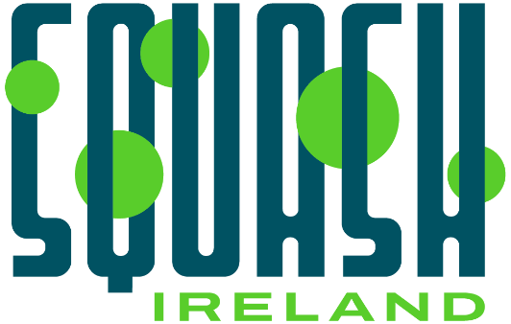

Role Specification: Squash Activation Officer(s) x 4 (Part-time / Flexible)
About Squash Ireland
Squash Ireland is the National Governing Body for squash on the island of Ireland, recognised by Sport Ireland and Sport Northern Ireland, and affiliated with the World Squash Federation and the European Squash Federation. The organisation is responsible for the growth, development, governance, and promotion of squash across the island of Ireland, with a strong emphasis on increasing participation, inclusion, and engagement across communities.
Squash Ireland and the sport of squash have developed rapidly over the past several years, with membership up by circa 40% over three years, the number of affiliated clubs increasing by 27%, and tournament entries recording double-digit increases. In the area of high performance, Ireland’s top-ranked squash players are on an upward trajectory, with ambitions to represent Ireland at the 2027 European Games and 2028 Olympic Games.
Squash Ireland gained High Performance Development Sport status for the first time, became a member of the Olympic Federation of Ireland, and secured several new funding streams across participation and performance, including support from Sport NI for the first time in more than a decade. Squash Ireland has been shortlisted for National Governing Body of the Year for two consecutive years, and in our next phase of development there will be a strong emphasis on increasing participation, particularly among junior players. The recruitment of four provincially based Squash Activation Officers demonstrates our commitment to this.
About the role
Squash Ireland is seeking to identify four part-time Squash Activation Officers located in each of the four Provinces to deliver programmes, coaching, and practical support to local communities. Squash Activation Officers will deliver coaching and programmes in a range of settings, including clubs, schools, third-level institutions, and community groups. They will support participation-focused programmes designed to increase squash participation by introducing the sport to new audiences and supporting sustainable, longer-term participation pathways.
The successful candidates will have an in-depth understanding of squash and the ability to deliver programmes and sessions to children, beginners, and a wide range of participants, including people with disabilities and those from disadvantaged communities.
Key Responsibilities
- Deliver high-quality squash taster sessions and participation programmes for children, young people, and adults.
- Support the development of sustainable participation pathways within clubs, schools and third level institutions.
- Work collaboratively with the Provincial Associations to identify opportunities to deliver coaching and programmes designed to increase participation.
- Work collaboratively with schools, clubs, community organisations, Local Sports Partnerships, and councils to identify opportunities for growth and funding.
- Act as an ambassador for Squash Ireland and the respective Provincial Association, representing the sport and the National Governing Body positively and professionally.
- Adapt delivery to support inclusion, diversity, and accessibility for participants of all abilities.
- Contribute to monitoring, evaluation, and reporting requirements linked to grant funded programmes.
- Support volunteer engagement and local capacity-building where appropriate.
- Support and mentor coaches with a view to increasing the number of active coaches.
- Ensure full compliance with safeguarding, child protection, and organisational policies.
- Secure financial support for the Squash Ireland development function to increase capacity to deliver impactful programmes.
Essential Requirements
- Demonstrable squash experience and sport-specific knowledge and a recognised squash coaching qualification.
- Confidently leading sessions with children and/or adults, providing an enjoyable and engaging introduction to the sport.
- Comfortable working within school and community environments.
- Strong interpersonal skills and ability to act as an ambassador.
- Garda vetting/Access NI (or willingness to complete prior to commencement) and valid safeguarding certification.
- Access to own transport and the ability to travel regionally.
- A desire to build the number of hours/days per week in the Squash Activation Officer role through a proactive approach.
Desirable Experience
- Experience working with participants with additional needs.
- Established relationships with Local Sports Partnerships, councils, or community stakeholders.
Further Information
- 4 x part-time Squash Activation Officers at circa 10 flexible hours per week (located in each of the four Provinces)
- The role requires flexibility to work during traditional office hours as well as evenings and weekends depending on programme delivery.
- Flexibility to increase time commitment and to respond promptly when opportunities arise.
- Squash Activation Officers will report to the Club & Community Development Officer (Republic of Ireland / Northern Ireland).
Pre-Appointment Requirements
The appointment is subject to:
- Safeguarding, reference, and vetting checks.
How to Apply
Applications must be submitted by email with the subject line: ATTN: Squash Activation Officer, and should include your preferred Province and a short cover letter and CV. Please send applications no later than 27 March 2026 to:
Scott Graham
CEO, Squash Ireland
Email: scott.graham@squashireland.ie

